1st Grade Unit 2: Place Value, Comparison, Addition and Subtraction of Numbers to 20
During Unit 2 your child will be working on the following math concepts:
Concept or Skill | Example
1. Count to 120, starting at any number less than 120. Read & write numerals and represent a number of objects with a written numeral. | 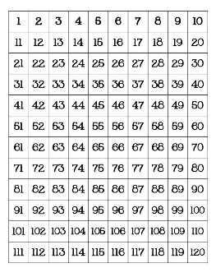
2. The numbers from 11 to 19 are composed of a ten & one, two, three, four, five, six, seven, eight or nine ones. | 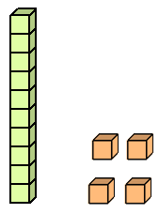
3. Solve addition and subtraction problems using a variety of strategies | Counting on/ Counting up  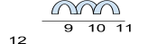9 + 3 = 12  Make a ten/ Bridge to ten  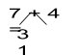  7 + 3 = 10  10 + 1 = 11
4. Decomposing a number leading to a ten | 13 – 4 = ?  13 - 3 = 10  10 – 1 = 9
5. Using the relationship between addition & subtraction | If 8 + 4 = 12, then 12 – 8 = 4
6. Determine an unknown number in an addition or subtraction equation relating three whole numbers. | 8 + ? = 11 5 = 3 + ? 12 - ? = 6

