1st Grade Unit 5:Place Value, Comparison, Addition and Subtraction of Numbers to 120
During Unit 5 your child will be working on the following math concepts:
Concept or Skill | Example
1. Count by ones to extend a counting sequence to 120 | 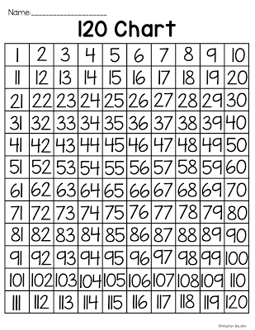
2. Count by tens from any number to extend a counting sequence up to 120 | Start at 23 and count by 10s  23 - 33, 43, 53, 63  Start at 2 and count by 10s  2 - 12, 22, 32, 42
3. Use models and write to represent equivalent forms of tens and ones to 100 | 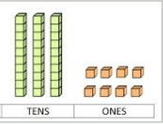  Long (Ten’s) Cubes (1’s)  I made ____.  I used ___ tens and ___ ones.
4. Use symbols <, >, and = to compare numbers to 100 | 18 is greater than 12 88 is less than 90  18 > 12 88 < 90
5.Identify numbers that are 10 more or 10 less than a given number | 10 more than 49 is 59 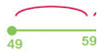  (Start on the left and add going right)  10 less than 59 is 49  (Start on the right and subtract going left)
6. Add multiples of ten on the empty number line | 48+10=58  58+10=68
7. Identify 100 more or 100 less from any given number within  1,000 | 100 more than 400 is 500  (Start on the left and add going right)  100 less than 500 is 400  (Start on the right and subtract going left)

