First Grade February Newsletter
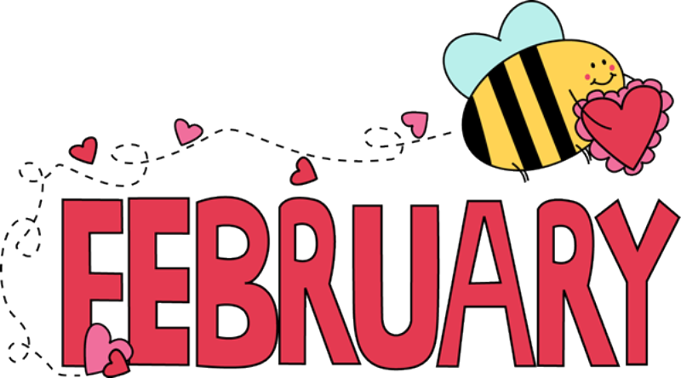
Dates to Remember·
Valentine’s Day and 100th Day of School on Friday, February 14th

Winter Break February 17th-21nd

PALP 2/28 from 8:30-9:00

Intrepid trip 2/24

We can’t believe this month we will be celebrating our 100th day already! The
time has flown by so fast and we have enjoyed getting to know your kids and seeing them learn and grow!

Reading: We have started our 5th Reading Unit- “Readers Have Big Jobs to Do”. Students will learn to take on more of a responsibility using strategies to take charge in their own reading, to set their own agenda, and to get through the hard parts by themselves. The students will learn to balance their reading energies between word solving and meaning making so that their experiences with texts are well-rounded, thoughtful, efficient, and meaningful.

Writing: We are working on “Writing Reviews”. Students have learned to write opinion pieces first based on collections they have, then writing to persuade others, and then finally writing book reviews. So far, they seem to love a good argument! To support your child at home, ask them their opinion on something like, their favorite book, movie, toy, vacation etc. Then ask them to give reasons to convince or persuade you that it’s the best. For example, if your child says, “Central Park is the best park in NY!”, ask them to give reasons and examples to support this claim. Maybe disagree with them, arguing Riverside Park is better. Help your child realize a good argument should be convincing.
Our next unit is Scenes to Series. Students will experience writing fictional works using character, plot, and setting. Students will create a pretend character and give that character adventures in more than one booklet. Students will then continue to study what makes a story exciting and still realistic, so it has more heart. The children will bring the characters to life by describing what they do, say and think.
Word Study: In Unit 3, we will be reading carefully, looking all the way through words, getting to know some common endings, investigating different sounds the -ed can make, the tricky, and blends come as endings.

Math: We will be moving on to Unit 3 in Math, Ordering and Comparing Length. Students are first learning about non-standard units of measurement, like using a piece of string or their shoe, then will learn how to use centimeters to measure, and finally learn to represent and interpret data.

Science: In Science, we will be getting ready for the Science Fair. Students are being introduced to
The topic of Offsprings -How do animal and plant offspring defend themselves when they are young and are growing up? Students will gather evidence about how parent’s help protect and how offspring prepare to learn to survive on their own.

Social Studies: We are working on Unit 2, Families Now and Long Ago, where students compared and contrasted families in the past, technology, tools, communication, and transportation.

Thanks so much for all your continued support!

