First Grade December Newsletter

Dates to Remember
- 12/12-Winter Theatre Performance
(We are performing)
- 12/16-Multicultural Interview at 1:40pm (in the classroom)
- 12/18-Field Trip to Theatre works
- 12/23-1/1 Winter Break

Thank you again to all our families for such a successful Fall parent/teacher conference as well as open school session. We hope you enjoyed both experiences and now have an even deeper insight into your child’s academic and social growth in our classroom!

Reading: During reading workshop, students are being word detectives, learning a multitude of strategies to figure out unknown words and tricky parts of their books. Some strategies we are using are: thinking of familiar words to figure out unknown words, thinking about what makes sense in the context of a sentence, looking at words part by part instead of letter by letter, rereading when something doesn’t sound right, and using pictures as clues. Hopefully, your child has come home sharing some excitement over their secret missions.

In addition to our class read-alouds, shared reading, and reading workshop, we are visiting the school Library each week, so please help your child develop good habits by remembering to return books weekly.

Writing: In writing, we just finished Unit 2, informational How-To Books. Students did a great job teaching their readers step by step with explicitness, clarity, and sequence. They did a great job writing introductions, conclusions for the first time. They are becoming more confident elaborating by giving advice to their readers and breaking down information with precise actions. Stop by and take a look at the How To Books on the bulletin board.

In our next unit, we will go more in depth by writing Nonfiction Chapter books. This unit prepares children to write information texts of all sorts across this year’s curriculum. Believe it or not, your 1st grader has many areas of expertise that they would love to teach others about such as, biking, seasons, pets, being a sister/brother, holidays, baseball, swimming, school, piano, etc.

Science: Our first grade scientists have started a new science curriculum and are learning about animal and plant relationships.
Students play the role of marine scientists. In their role, students apply their understanding of plant and animal defense structures to explain to aquarium visitors how a sea turtle and her offspring can defend themselves from ocean predators when they are released into the wild.
The Problem: An aquarium will soon release Spruce, the sea turtle, back into the ocean. The visitors are concerned about how Spruce can survive in the ocean, particularly
since sharks live in the area. Further, they wonder if Spruce has offspring, how will the babies survive in the ocean?
Students’ Role: Students take on the role of marine biologists, investigating the problem and advising the staff of an aquarium how to explain to their visitors why they shouldn’t be concerned about the aquarium’s plan to release the sea turtle into the ocean.
What Students Figure Out: In four chapters, students investigate animal and plant defenses, the behavior of both parents and offspring that help offspring survive, and the similarities of plant and animal parents and their offspring. Throughout the unit, students build models of animal and plant defenses to communicate to aquarium visitors that while there are predators in the ocean, sea turtles have structures such as shells and camouflage that can protect them.

Math: We are continuing station based rotations during math workshop as we now start Unit 2, which serves as a bridge from problem solving within 10 to work within 100. Students will begin to solve addition and subtraction problems involving teen numbers. In Unit 1, students were encouraged to move beyond the Level 1 strategy of counting all to the more efficient counting on. Now they go beyond Level 2 to learn Level 3 decomposition and composition strategies, informally called make ten or take from ten.
9 + 6 = __ 9 + 6 = __ 9 + 6 = __
Level 1: Count all Level 2: Count on Level 3: Decompose an addend to compose
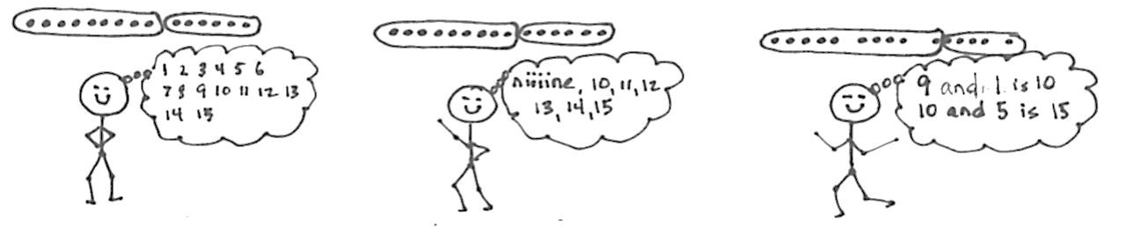
Though many students may continue to count on as their primary means of adding and subtracting, the larger purpose of composing and decomposing ten is to lay the foundation for the role of place value units in addition and subtraction. Please practice basic addition and subtraction facts to 10 (ex: 7 +2, 6 + 3 etc.), doubles facts (4 + 4, 6 + 6, 7 + 7) to help support your child’s mathematically fluency.
By the end of the unit, students will be able to identify coins, know their values, and easily add pennies and dimes using their knowledge of place value.

Social Studies: In Social Studies we are working on our 2nd Unit called, Families Now and Long Ago. Students are comparing and contrasting families in the past, as well as, learning how families grow and change over time. We had a great Field trip to the Native American Cultural Center, where students learned about New York long ago. For Thanksgiving we shared different family traditions, and what we are most thankful for.

In addition, the multicultural interviews, due on Monday, December 16th, are a great way for students to compare life when their grandparents or relatives were kids with their own experiences. It is also an opportunity to learn and discuss your family culture and traditions.

Word Study: Students learned in TC Word Study Unit 2: Silent e can change the vowel, you can pull apart double consonants, vowel teams make a long sound, 3-letter blends stick together at the beginning of words, compound words fit two words together, and sometimes words have parts that look alike. In Unit 3, we will be reading carefully, looking all the way through words, getting to know some common endings, investigating different sounds the -ed can make, the tricky, and blends come as endings.

Happy December!

