First Grade Unit 4: Geometry: Identify, Compose, and Partition Shapes

During this unit, students you will be working on these math concepts:

Concept | Example
Shape Attributes  Closed Shape vs. Open Shape  Corners (vertices) , Straight Sides | 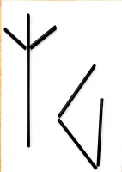  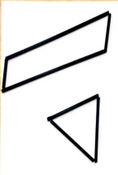  Open Shapes  Closed Shapes
Attributes of 2-D Shapes  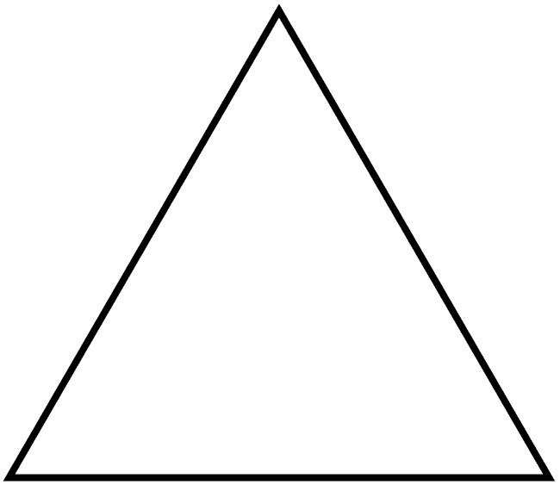  Triangle  Square  Rectangle  Circle  Trapezoid  Rhombus  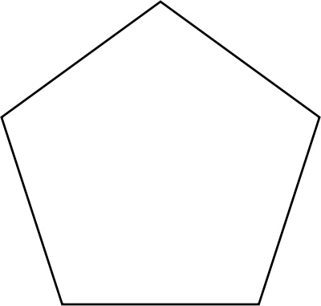  Pentagon  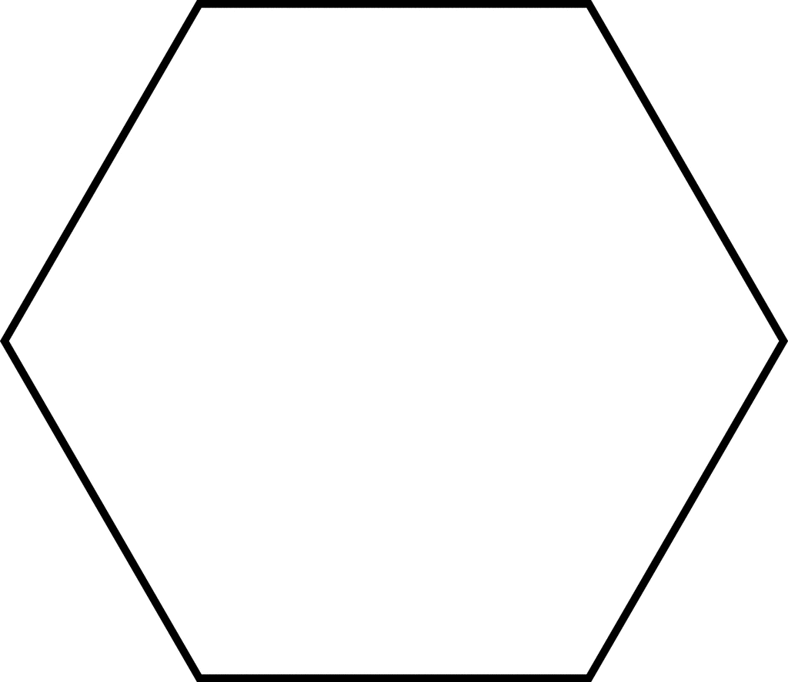  Hexagon  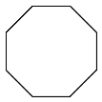  Octagon | Name # of sides # of corners  Triangle 3 3  Square 4 4  Rectangle 4 4  Circle 0 0  Trapezoid 4 4  Rhombus 4 4  Pentagon 5 5  Hexagon 6 6  Octagon 8 8
Attributes of 3-D Shapes  Cone  Cube  Cylinder  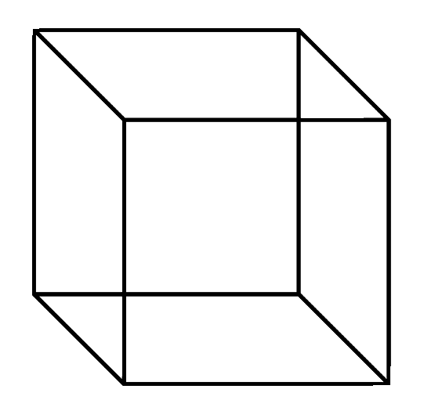  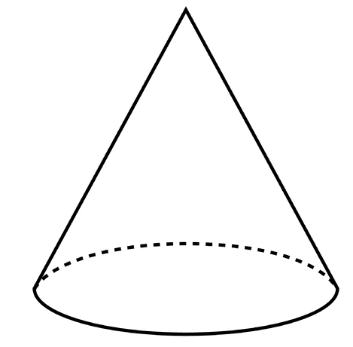  Rectangular Prism  Sphere  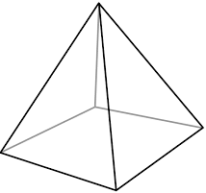  Pyramid | Name Faces  Cone 1 oval face  Cube 6 square faces  Cylinder 2 oval faces  Rectangular 6 rectangular faces  Prism  Sphere NO FLAT FACES  Pyramid 1 square face, 4 triangular faces
Partitioning Shapes (equal parts)

Cutting a shape into equal parts.
Halves, quarters (fourths)
Partitioning Shapes (unequal parts)

