P1st Grade Unit 3: Ordering And Expressing Length and Measurements as Numbers
During Unit 3 your child will be working on the following math concepts:
Concept or Skill | Example
1. Order three objects by length. | 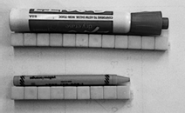  The marker is 12 cubes long and the crayon is 9 cubes long.
2. Compare the lengths of two objects indirectly by using a third object.  (For example: I am shorter than mom. My little sister is shorter than me. Therefore, my little sister is also shorter than mom.) | 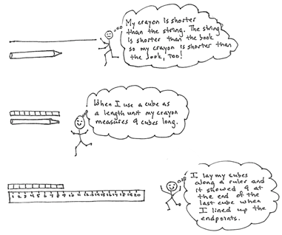
3. Accurately measure the length of an object using the same size informal units from endpoint to endpoint with no gaps or overlaps.  (Example: Using the same size paper clips to measure a pencil) | 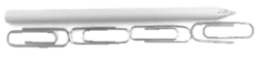  The pencil is about 4 paper clips long.
4. Organize, represent, and interpret data with up to three categories; ask and answer questions about the total number of data points, how many in each category, and how many more or less are in one category than in another. | 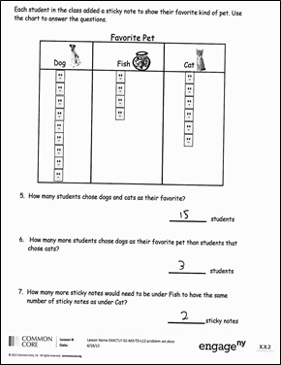
5. Tell and write time in hours and half-hour using analog and digital clocks. | 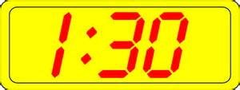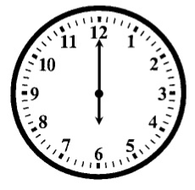  Digital Clock Analog Clock

age 1 of 2
1st Grade Unit 3:

