Typical Day for Class 1-210
Below is our schedule and specials, special events, etc. Literacy (Reading and Writing)
are usually taught in the morning and math, science and social studies in the afternoon.
In the morning, we start with a math message of the day or ECAM centers.
Unpack/Homework Check: Weekly 1st grade packet
Morning Meeting: messages, calendar, weather, and attendance. This includes new
words of the week. Math Talks, and ECAM Centers
Writer’s Workshop: Small Moments, How to Books, Non-fiction Chapter Books, Writing Reviews, Poetry and Songs, From Scenes to Series, Independent Writing Projects. Publishing Parties
Reading Workshop: Building Good Habits, Word Detectives: Use all they know to Solve Words, Learning About the World: Reading Non-fiction, Readers Get to Know Characters By Performing Their Books, Readers Have Big Jobs to Do: Fluency, Phonics, and Comprehension, Meeting Characters and Learning Lessons A Study of Story Elements, Reading Nonfiction Cover To Cover: Non-fiction Book Clubs,.
Word Study: Foundations
Lunch/Recess
Math: Rotations- 3 groups that move from lesson, to independent work, to centers.
Unit 1-Addition and Subtraction of numbers to 10 with Fluency
Unit 2-Place Value Addition and Subtraction of numbers to 20
Unit 3-Length and Measurement with Numbers
Unit 4-Geometry: Identify, Compose, and Partition Shapes
Unit 5- Place Value Comparisons Addition and Subtraction of numbers to 100
Science: Animals & Plant Defences & LIght & Sound
Social Studies: Families and Communities are Important, Families, Now and Long Ago, The Community, Restaurant Unit-Jobs in our Community.
Snack/Pack/Dismissal Restaurant
1-210’s Tentative Specials Schedule
Monday | Tuesday | Wednesday | Thursday | Friday
Music  Period 2  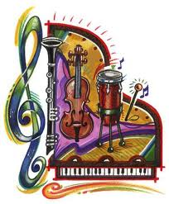 | Art  Period 2  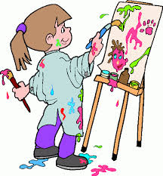 | Movement  Period 2  Library Period 5 | Gym  Period 5  Gardening every other week Period 7 | 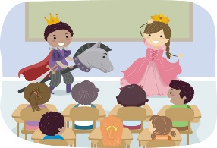Theatre  Period 3  Chess Period 7

