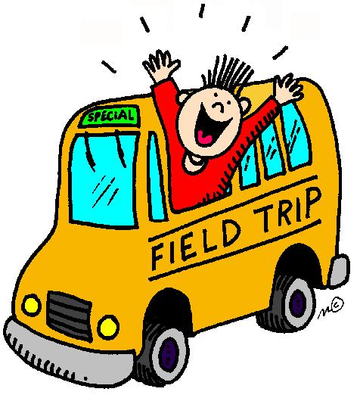Class 1-210 Field Trips
*Below is a list of the upcoming trips for the 1st part of the year with dates and prices. Please KEEP THIS for your reference and scheduling purposes. I will confirm chaperones prior to each trip and collect chaperone money at that time. Please sign each attached sheet! The Board of Education requires separate trip signed sheets. Please return signed with money in a closed labeled envelope with your child’s name by Friday, October 18th.* Total for each child should be $24.00
Where | When | Why | Cost | Transportation
St. Agnes Library  444 Amsterdam Ave. | Monday, October, 7nd @ 9:15 | To discuss Unit 1  J ust right books and  Resources available to you (Reading) | Free | Walk
Fire Museum  278 Spring Street. | Friday, October 25th @ 9:20 | To study the history of our city through exhibits of memorabilia, teaches students about fire prevention (Social Studies) | Child $4.00  Adult $8.00 | Bus
Children’s Cultural Center of Native America | Tuesday, November 19 @ 9:20 | To study past, present and future of Native America | Child $10.00  Adult$10.00 | Bus
Theatreworks USA@  Town Hall Theater  Dragons Love Tacos | Wednesday, December 18@ 9:20 | Reading and storytelling | Child $10.00  Adult $10.00 | Bus
- - - - - - -cut off and keep - - - - - -
My child will be attending all of the trips from September to December. Enclosed
_____________________________ _______________________________
Child’s Name Parent Signature
I would like to attend the following trips:
_________________________________________________________________

