1st Grade Unit 1: ADDITION strategies within 10
During Unit 1 your child will be learning the following math concepts:
Concept or Skill | Example
Count on 1, 2, or 3 to find sums | 7 + 3 = ?  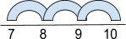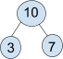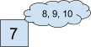
Use Commutative Property of Addition | 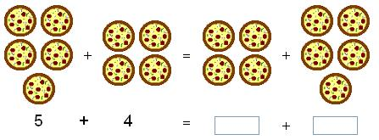
Show all combinations of 10 | 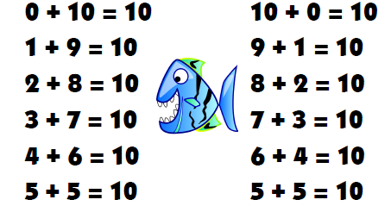
Use the Associative Property of Addition to add 3 addends | (1 + 2) + 4 = 2 + (1 + 4)  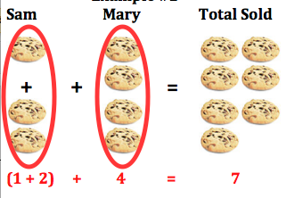
Determine if an equation is true or false | 5 + 2 = 3 + 4

